CONTRACT TO EXHIBIT

To reserve exhibition space, please fill in the required details below and fax or e-mail the completed form to the Conference Secretariat
Company Name (For Invoicing)
Company Name (For Exhibition Facia)
Fascias are limited to 22 characters
Exhibition Contact Person:
Physical Address:
Postal Code: |  |  |  | Country:
Telephone: |  |  |  | Fax:
E-mail: |  |  |  | Website:
We hereby apply for exhibition space at the SAHHA Conference 2026 and require the following:
FULL SCHELL SCHEME STAND

We require x 9m2 stand with full Schell Scheme package at ZAR 55 000.00

We require x 9m2 exhibition space only at ZAR 50 000.00

STAND NUMBER

Please list the stand number/s of your choice –
Stand Number/s: 1st Choice 2nd Choice 3rd Choice

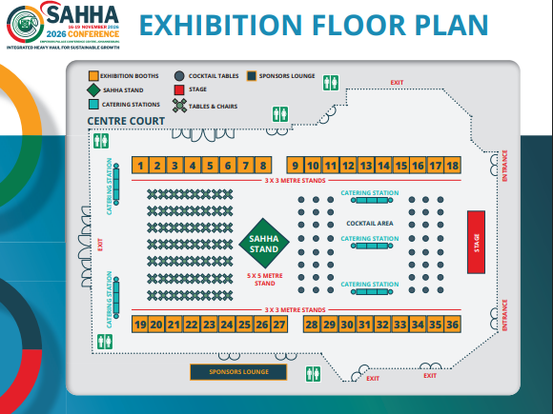

CONTRACT
Signed on behalf of the company
Date Signed:
Designation:
Name:
Signature:
To confirm your booking, the payment is due upon receipt of the invoice.
By signing the above, I hereby confirm that I am duly authorized to sign on behalf of the company. We agree to the standard terms and conditions and any written amendments that may be imposed by the organizers. Failure to attend, pay in a timely manner, or otherwise comply with the organizers’ regulations can result in cancellation and payment of consequential damages. This offer is not provisional; it creates a binding contract upon acceptance by the organizers. Please note: Full prepayment is required to exhibit at the SAHHA Conference 2026.
Tel.: +27 21 836 8315 E-mail: info@sahhaconf.co.za

